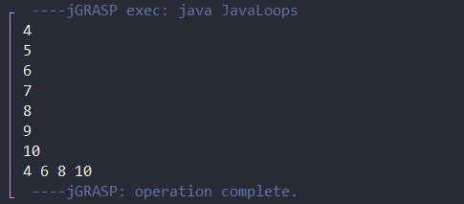

I achieved the correct output by creating a FOR loop that goes through each integer in the array. I then used the modulus (%) operator to divide the current integer(i) by 2 and if there was a remainder of 0, that would mean the number is EVEN.